

**ALAGAPPA COLLEGE OF TECHNOLOGY**

**ANNA UNIVERSITY-600025**

**NM Assignment / Digital Marketing**

|  |  |  |
| --- | --- | --- |
| NAME | REG.NO | Naan Mudhalvan ID |
| Nikita Rajakumar | 2020308026 | 7EECC0CF6CEE85DA0EB4880D14C571A4 |

1. **Create a blog or website using Blogpost Customize the theme design and post new article with 500 words.**

[Cocoa crush (cocoacrush123.blogspot.com)](https://cocoacrush123.blogspot.com/2023/10/cocoa-crush.html)

2. Create a New Facebook Business Page and post one social media poster for your brand.

[Cocoa crush | Facebook](https://www.facebook.com/people/Cocoa-crush/61552721260191/)

3. Create and design a social media advertisement poster using canva.

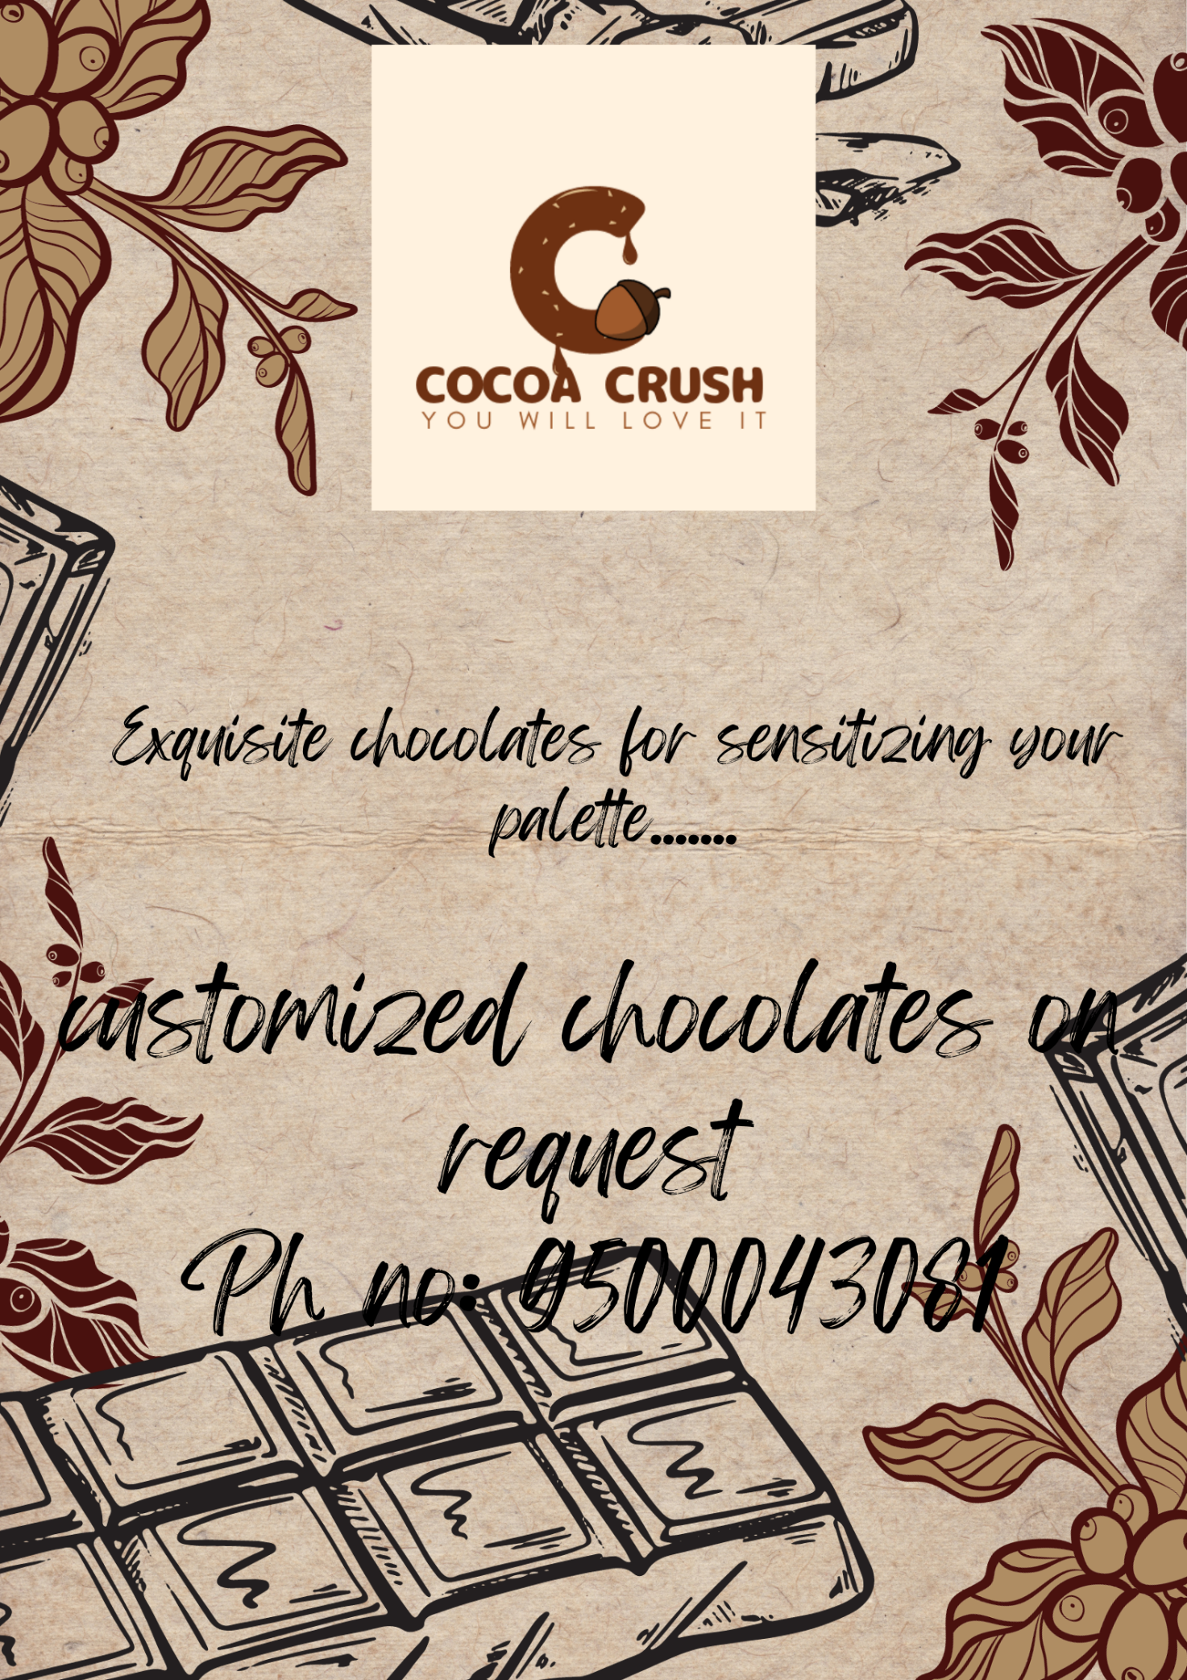

4. Create email newsletter design using MailChimp or canva tool.

